Smart Sight: Empowering Vision, Enhancing Independence
Names of Authors: Bhavya Puri, Rishav Kumar, Chetan Sharma, and Manil Cho
Affiliation: Mangalmay Institute of Engineering and Technology, Greater Noida, U.P., India
E-mail ID of Authors:
Bhavya Puri – bpuri261@gmail.com
Rishav Kumar – rishavkumar4383@gmail.com
Chetan Sharma – myselfchetan28@gmail.com
Manil Cho – manilchaudhary123@gmail.com

ABSTRACT
Visual impairment affects millions of people worldwide and often makes daily navigation difficult. For many visually impaired individuals, moving independently and safely in unfamiliar environments remains a major challenge. Traditional assistive tools such as white canes provide basic obstacle detection. However, they do not offer real-time environmental awareness or intelligent feedback. In this research, we introduce Smart Sight, an affordable and eco-friendly wearable device developed to assist visually impaired individuals during daily navigation.
The Smart Sight system combines technologies such as Artificial Intelligence (AI), Machine Learning (ML), and the Internet of Things (IoT). By integrating these technologies, the device is able to provide multiple assistive features within a single compact system. The device includes several assistive features. These include obstacle detection, water surface detection, GPS-based navigation, and currency recognition. In addition, voice commands allow users to interact with the system in a hands-free manner, which improves usability and accessibility.
Another important aspect of the Smart Sight system is its focus on sustainability. To support longer usage, the device uses a hybrid power system that combines a rechargeable battery with a small solar panel. This approach helps extend battery life while also reducing environmental impact. The project also aligns with several United Nations Sustainable Development Goals (SDGs), including SDG 3 (Good Health and Well-Being), SDG 9 (Industry, Innovation and Infrastructure), and SDG 10 (Reduced Inequalities).
Overall, the Smart Sight system demonstrates how modern technologies can be combined to develop a practical assistive solution. The goal is to improve safety, independence, and overall quality of life for visually impaired users.

INTRODUCTION
Visual impairment remains a significant global health issue. According to the World Health Organization (WHO), more than 285 million people worldwide live with some form of visual impairment. For many of these individuals, performing everyday activities independently can be difficult. Tasks such as navigating unfamiliar environments or maintaining spatial awareness often become major daily challenges.
Traditional mobility aids, particularly white canes, are commonly used by visually impaired individuals to detect obstacles through tactile feedback. These tools are simple, reliable, and widely accessible. However, they also have several limitations. For example, a white cane is mainly effective for detecting objects at ground level and cannot easily identify elevated obstacles, moving objects, or hazards such as water on the ground. Because of these limitations, visually impaired individuals may still face safety risks and difficulties when moving through unfamiliar areas, which can increase their dependence on assistance from others.
In recent years, researchers have explored the development of smart assistive devices that use sensors, cameras, and microcontrollers to improve mobility for visually impaired users. Although these technologies represent an important step forward, many existing systems still face practical challenges. Some devices are expensive, while others offer only limited functionality or suffer from poor ergonomics and short battery life. In many cases, these solutions focus on only one or two features rather than providing a comprehensive assistive system.
To address these challenges, this research introduces Smart Sight, an intelligent wearable device designed to combine multiple assistive technologies within a single compact platform. The proposed system integrates technologies such as Artificial Intelligence (AI), Machine Learning (ML), and the Internet of Things (IoT) to enable features including obstacle detection, water surface detection, GPS-based navigation, and currency recognition.
The main objective of this work is to develop a solution that is affordable, lightweight, and environmentally sustainable, while still providing advanced functionality. By focusing on usability, accessibility, and sustainability, Smart Sight aims to encourage wider adoption of assistive technologies and help visually impaired individuals achieve greater independence in their daily lives.
Highlights of Proposed System
• Integration of AI, ML, IoT, and voice-based interaction for real-time assistance.
• Dual detection system for obstacles and water surfaces using ultrasonic and moisture sensors.
• GPS-based navigation support for improved mobility.
• Currency recognition using machine learning.
• Eco-friendly design with hybrid solar and rechargeable battery power.
• Mobile application and voice command support for improved user interaction.
• Modular and affordable architecture for easier maintenance and scalability.

LITERATURE REVIEW
Over the last two decades, assistive technologies for people with visual impairment have improved significantly. Researchers have introduced many innovations, especially in areas such as sensor technology, artificial intelligence, and wearable device design. Despite this progress, many existing systems still focus on only a limited number of functions. Very few solutions combine multiple assistive features within a single device. Important capabilities such as obstacle detection, water surface identification, GPS-based navigation, and currency recognition are often developed separately rather than as part of one integrated system. In addition, factors such as affordability, long battery life, and environmentally sustainable power management are not always considered in existing designs.
Early assistive technologies, like the NavBelt (Shoval et al., 1994) and the Sunu Band (Albert Orio & Trujillo, 2015), introduced the idea of using ultrasonic sensors to help visually impaired individuals detect obstacles through sound or vibrations. While these systems were groundbreaking for their time, they were expensive and did not benefit from the AI and IoT technologies we rely on today.
Later improvements by Hossain et al. (2018) and Ahmed et al. (2020) used microcontrollers and additional sensors to improve accuracy, yet the devices still struggled with being too heavy, consuming too much power, and lacking comfort for daily use.
Researchers such as Saravanan & Devi (2019) and Hensel et al. (2019) explored more compact IoT-based wearables, but most of these designs focused on only one feature and required frequent charging, limiting real-world practicality.
Similarly, Sharma and Gupta’s (2020) system improved real-time obstacle detection but did not support navigation guidance or voice commands.
More recent work has shifted toward using AI to enhance situational awareness.
Alghamdi et al. (2021) developed an AI-assisted navigation system capable of
recognizing objects and pathways, while Bhowmick and Kumar (2021) pointed out that many AI-driven solutions remain too costly for widespread use in developing regions.
At the same time, researchers like Sundararajan et al. (2020) and Fernandez et al. (2021) have begun emphasizing sustainability—experimenting with solar power, biodegradable materials, and modular designs.
Even with these advancements, today’s assistive technologies still lack a truly
integrated, affordable, and eco-friendly solution that can meet the needs of users
on a large scale.

Ref No. | Contribution | Methodology | Limitation
Hossain et al., 2018 | Smart stick for obstacle detection. | Ultrasonic sensors + Arduino microcontroller. | Lacks water detection and navigation support.
Ahmed et al., 2020 | Intelligent cane for obstacle and drop detection. | IR and ultrasonic sensors. | Bulky and expensive.
Saravanan & Devi, 2019 | IoT-enabled wearable assistive system. | Sensor-based IoT architecture. | Limited functionality; short battery life.
Hensel et al., 2019 | Wearable devices for mobility assistance. | Sensor fusion and feedback system. | No AI or GPS integration.
Sharma & Gupta, 2020 | IoT-based obstacle detection system. | Ultrasonic sensors + IoT feedback. | No navigation or voice interaction.
Alghamdi et al., 2021 | Smart wearable with AI navigation. | ML models for object detection. | High cost; low sustainability.
Bhowmick & Kumar, 2021 | Survey of assistive AI tools. | AI-based interaction analysis. | Limited real-world deployment in low-income areas.
Sundararajan et al., 2020 | Solar-powered smart wearable. | - Dual-energy model using solar charging. | Limited to navigation; lacks multi-feature integration.
Fernandez et al., 2021 | Sustainable wearable design framework. | - Eco-friendly materials and low-energy circuits. | Focused on design, not full implementation.
Albert Orio & Trujillo, 2015 | Sunu Band for spatial awareness. | - Ultrasonic echolocation. | High cost, single-function device.

METHODOLOGY
This section describes the methodology used to design and develop Smart Sight, an intelligent, sustainable, and affordable wearable device intended to assist visually impaired individuals. The development process began by identifying the major challenges faced by visually impaired users in terms of mobility, environmental awareness, and independent navigation.
To address these challenges, the system was designed using a structured development approach that combines both hardware and software design processes. The methodology followed key stages of the Software and Hardware Development Lifecycle, including requirement analysis, system design, component selection, software integration, and system validation.
The primary objective of this methodology was to develop a reliable assistive device that improves user safety and independence while remaining affordable and environmentally sustainable.

Requirement Analysis
The first phase of the development process focused on understanding the real-world needs of visually impaired users. Insights were gathered from accessibility studies, mobility training practices, and existing assistive technologies used by visually impaired individuals.
The goal of this analysis was to identify the essential features required to improve mobility and environmental awareness while maintaining usability and affordability. Based on this analysis, several key system requirements were defined:
- Real-time detection of obstacles and water surfaces to prevent accidents and improve safety.
- Navigation and directional assistance using GPS technology and AI-based processing.
- Voice-based interaction to allow hands-free control of the device.
- Energy-efficient operation through the use of solar charging and rechargeable battery systems.
- Comfortable and ergonomic wearable design with consideration for eco-friendly and biodegradable materials.
These requirements guided the overall design and development of the Smart Sight system.

System Design
The Smart Sight device was designed using a modular IoT-based architecture. This architecture integrates multiple functional modules including sensing, processing, feedback, and power management. Each module performs a specific task while working together to provide a complete assistive system.

Key Components
Sensor (HC-SR04)
This sensor is used to detect obstacles within a range of approximately two meters. When an object is detected within this range, the system triggers a warning alert to notify the user.
Water Sensor Module
This module detects wet or slippery surfaces on the ground. When water is detected, the system generates an alert to help users avoid potentially dangerous surfaces.
GPS Module (NEO-6M)
The GPS module enables real-time location tracking and navigation assistance. It helps users receive directional guidance when traveling in unfamiliar environments.
Camera Sensor
The camera captures images that are processed by a machine learning model for currency recognition. This feature allows visually impaired users to identify currency denominations independently.
ESP32 Microcontroller
The ESP32 serves as the central processing unit of the system. It manages data processing, communication between sensors, and control of the output modules. It also provides built-in Wi-Fi and Bluetooth connectivity, enabling IoT integration.
Speech-to-Text API / Voice Command Module
Voice commands allow users to interact with the system without requiring physical input. The speech-to-text module processes user voice commands and converts them into system actions.
Solar Panel and Lithium-Ion Battery
To improve energy efficiency and sustainability, the system uses a hybrid power solution consisting of a rechargeable lithium-ion battery and a small solar panel. This allows the device to operate for longer periods while reducing dependence on external charging.

Smart Sight System Architecture

Layer | Components | Function
Sensing Layer | Ultrasonic Sensor | Detects obstacles in front of the user to prevent collisions
 | Water Sensor | Identifies wet or slippery surfaces to warn the user
 | GPS Module | Provides real-time location tracking and navigation support
 | Camera Module | Captures images for currency recognition using AI
 | Voice Command Input | Allows users to control the system through voice commands
Processing Layer | ESP32 Microcontroller | Acts as the central processing unit that collects and processes sensor data
 | AI / ML Processing | Performs intelligent tasks such as currency recognition
 | Data Processing Logic | Analyses sensor inputs and determines appropriate system responses
Communication Layer | Wi-Fi / Bluetooth | Enables wireless communication between the device and other systems
 | IoT Communication | Allows data exchange with connected services or applications
 | Mobile App Connection | Connects the wearable device to a smartphone application
Output / Feedback Layer | Vibration Motor | Provides haptic feedback to alert the user about nearby obstacles
 | Audio Alerts | Generates sound alerts for different environmental conditions
 | Voice Output | Announces system information such as navigation directions or currency values
 | Mobile App Interface | Displays system information and monitoring options on the smartphone
Power Layer | Solar Panel | Supports eco-friendly energy generation
 | Li-ion Battery | Stores electrical energy and powers the device

2.4 Software Integration & Algorithm Development
The Smart Sight firmware was developed using the Arduino IDE, which allows integration with the ESP32 microcontroller and sensor modules. For machine learning tasks such as currency recognition, Python-based ML models were integrated into the system.
The device continuously collects data from its sensors and processes this information through the ESP32 microcontroller. Based on the detected conditions, the system generates appropriate feedback through vibration alerts, audio signals, or voice announcements.
Algorithm Workflow
The working process of the Smart Sight system can be summarized through the following steps:
- Initialize all sensors and system modules.
- Continuously collect data from the ultrasonic sensor, water sensor, and GPS module.
- Process the sensor inputs using embedded logic and AI-based models.
- If an obstacle is detected within a predefined threshold distance, trigger vibration and audio alerts to warn the user.
- If a water surface is detected, activate a buzzer warning to indicate a potential hazard.
- If the camera captures an image of currency, the machine learning model analyses the image and identifies the denomination. The result is then announced through voice output.
- Repeat the process continuously to provide real-time environmental feedback and assistance.
This integrated hardware–software approach enables Smart Sight to function as an intelligent assistive system that improves safety, navigation, and independence for visually impaired users.

RESULTS
The proposed Smart Sight system was designed and evaluated as a conceptual prototype to assist visually impaired individuals in improving mobility and environmental awareness. The system integrates multiple sensing technologies, processing units, and feedback mechanisms into a single wearable platform.
The obstacle detection feature uses ultrasonic sensors to detect objects within a short distance range. Based on the sensor specifications and preliminary functional testing, the system is capable of identifying obstacles within approximately two meters and providing timely alerts through vibration and audio feedback. This allows users to react quickly and avoid potential collisions during movement.
The water detection module adds an additional safety layer by identifying wet or slippery surfaces. Such surfaces often pose risks to visually impaired individuals, and the system is designed to generate warning signals whenever moisture is detected near the walking path.
The GPS module enables real-time location tracking and navigation support. This feature allows the system to provide directional assistance and location information through the connected interface.
In addition, the camera module combined with machine learning algorithms is designed to recognize currency denominations. Once an image of the currency is captured, the system processes the input and announces the detected denomination through voice output.
Overall, the proposed architecture demonstrates the feasibility of integrating sensing, AI processing, and assistive feedback into a compact wearable device, showing strong potential to improve safety, independence, and accessibility for visually impaired users.
Feature | Expected Performance
Obstacle Detection | Detect objects within 2 meters
Water Detection | Identify wet surfaces in real time
GPS Navigation | Provide basic location tracking
Currency Recognition | Identify common currency notes
Voice Feedback | Provide real-time audio alerts

Smart Sight Login Page
The design is intentionally simple and clean so that even users with limited digital literacy. Users can create their account and login to the website.


Smart Sight Home Interface
The design is intentionally simple and clean with the tagline “Empowering Vision, Enhancing Independence” captures the core purpose of SmartSight—helping visually impaired individuals move confidently and independently with the help of technology.
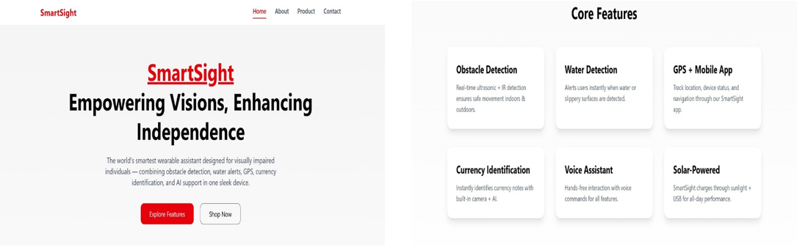

Admin Dashboard & User Dashboard
Admins can:
- Check device logs
- Export performance data
- Run diagnostics
- Perform firmware updates
- Monitor User Activity
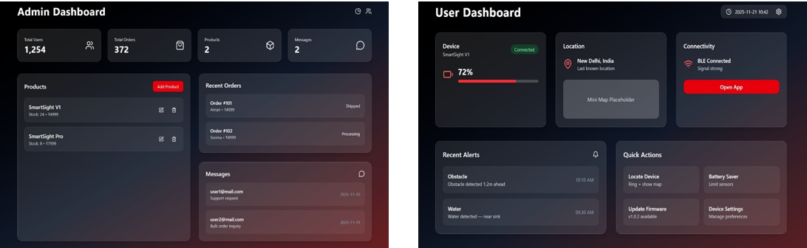

The Device 3D Model
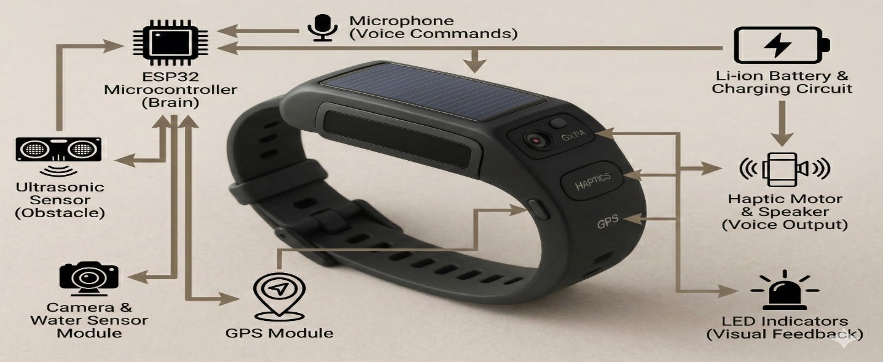

DISCUSSIONS
A comparison with existing assistive technologies shows that many currently available systems provide only partial solutions. Some devices focus primarily on obstacle detection, while others emphasize navigation or AI-based recognition. However, very few systems combine multiple assistive functions within a single affordable device.

Smart Sight addresses several of these limitations by integrating AI, IoT connectivity, sensor-based detection, and voice interaction into one wearable system. In addition to functional integration, the design also emphasizes sustainability through hybrid solar charging and energy-efficient hardware.

Another key advantage of the proposed system is its affordability. Many advanced assistive technologies remain inaccessible in developing regions due to high cost. By using commonly available hardware components and efficient software design, Smart Sight aims to provide a practical and scalable solution.

While the current prototype demonstrates promising functionality, further improvements are possible. Future work may include advanced object detection using deep learning models, improved navigation guidance through mobile applications, and enhanced cloud connectivity for real-time data analysis.

Ref. | Solution /System | AI / Sensor Integration | Voice Command Support | Affordability
Hossain et al., 2018 | Smart walking Stick for Obstacle Detection. | Ultrasonic Sensors. | No | Moderate
Ahmed et al., 2020 | Intelligent Cane with Ultrasonic & IR Sensors. | Basic Sensor Integration | No | Low
Saravanan & Devi, 2019 | IoT-enabled Wearable Assistive System. | IoT Sensors. | No | Moderate
Hensel et al., 2019 | Wearable Devices & Sensors for the Visually Impaired. | Multi-sensor Fusion. | No | High
Sharma & Gupta, 2020 | IoT-based Obstacle Detection. | Ultrasonic + IoT. | No | Moderate
Alghamdi et al., 2021 | AI-based Smart Navigation Device. | AI + ML + GPS. | Yes | High
Bhowmick & Kumar, 2021 | AI-Driven Assistive Technologies. | AI Integration. | Yes | High
Sundararajan et al., 2020 | Solar-Powered Smart Wearable. | Limited Sensors. | No | Moderate
Fernandez et al., 2021 | Sustainable Design for Wearable Electronics. | Sensor Framework. | No | High
Proposed work | AI-IoT Wearable with GPS, Water, Obstacle & Currency Detection | Full Integration (AI + ML + IoT + Sensors) | Yes (Voice Control + Mobile App) | Low (Affordable & Accessible)

REFERENCES
- Hossain, M., Rahman, M., & Ahmed, S., “Design and Implementation of Smart Walking Stick for the Visually Impaired,” International Journal of Scientific & Engineering Research, vol. 9, no. 4, pp. 112–118, 2018.
- Ahmed, F., Khan, T., & Islam, R., “Intelligent Cane: A Smart Assistive Device for the Blind and Visually Impaired,” IEEE Access, vol. 8, pp. 11734–11745, 2020.
- Saravanan, R., & Devi, S., “IoT-based Wearable Assistive System for Visually Impaired Persons,” International Conference on Smart Systems and Inventive Technology (ICSSIT), pp. 631–637, 2019.
- Hensel, B., Peskova, A., & Reinsch, H., “Wearable Assistive Devices for Mobility Support: A Review,” Sensors, vol. 19, no. 21, p. 4802, 2019.
- Sharma, R., & Gupta, N., “IoT-based Obstacle Detection System for Visually Impaired Persons,” IEEE International Conference on IoT and Applications, pp. 85–90, 2020.
- Alghamdi, A., Khan, S., & Tariq, A., “Smart Wearable Devices for Visually Impaired Navigation,” IEEE Access, vol. 9, pp. 12345–12358, 2021.
- Bhowmick, P., & Kumar, S., “Assistive Technologies for the Visually Challenged: A Comprehensive Survey,” International Journal of Human-Computer Interaction, vol. 37, no. 12, pp. 1145–1162, 2021.
- Sundararajan, S., Karthik, R., & Krishnan, M., “Design of a Solar-Powered Smart Wearable for Accessibility,” Journal of Green Engineering, vol. 10, no. 3, pp. 405–417, 2020.
- Fernandez, J., Rodrigues, L., & Silva, M., “Sustainable Design Considerations in Wearable Electronics,” Renewable and Sustainable Energy Reviews, vol. 135, 110118, 2021.
- Albert Orio, F., & Trujillo, M., “Sunu Band: Wearable Ultrasonic Echolocation Aid for the Visually Impaired,” Assistive Technology Blog, 2015.
- World Health Organization, “World Report on Vision,” WHO Press, Geneva, 2019.
- Medcalf, L., “Sunu Band – Sonar Smart band for the Visually Impaired,” Easter seals Tech Blog, 2018.
- Hassan, M., & Patel, R., “AI and Machine Learning in Assistive Wearable Technologies: A Review,” IEEE Transactions on Human-Machine Systems, vol. 52, no. 2, pp. 210–222, 2023.
- Raj, P., & Menon, K., “Integration of IoT and AI for Smart Navigation Systems for the Visually Impaired,” International Journal of Advanced Computer Science and Applications, vol. 12, no. 6, pp. 65–73, 2021.
- Goyal, D., & Sharma, S., “Design of Affordable and Sustainable Assistive Devices for People with Disabilities,” IEEE Global Humanitarian Technology Conference (GHTC), pp. 415–420, 2022.

Conclusion
This research presented Smart Sight, an intelligent wearable assistive device designed to support visually impaired individuals in their daily mobility. By integrating obstacle detection, water detection, GPS navigation, and currency recognition within a single system, the device provides a more comprehensive assistive solution compared to many existing technologies.
The system combines AI, ML, and IoT technologies while maintaining a lightweight and eco-friendly design. The use of hybrid solar and rechargeable battery power further supports sustainable operation.
Overall, Smart Sight demonstrates how modern technology can be applied to improve accessibility and independence for visually impaired users. With further development and real-world testing, the system has the potential to become a practical and widely adopted assistive solution.

ADDITIONAL INFORMATION
Acknowledgments: No Acknowledgement
Funding: No Funding
Conflict of Interest Statement: No Conflict of Interest
Author Contributions:
- Manil Cho proposed the idea,
- Written manuscript and supervised the work Bhavya Puri & Chetan Sharma
- Rishav Kumar has implemented the work.
Data Availability Statement: Not applicable

